School Survey Results from Sunday September 18th, 2023

The Lady Melissa and Lady Janice ran surveys in the Seal Island area on Monday September 18. The Lady Melissa survey was 45 minutes and covered an area of 4km2. The Lady Janice survey was a little over an hour and covered an area of 10 km2.

Figure 1. Transects ran with respect to the German Bank and Seal Island boxes.

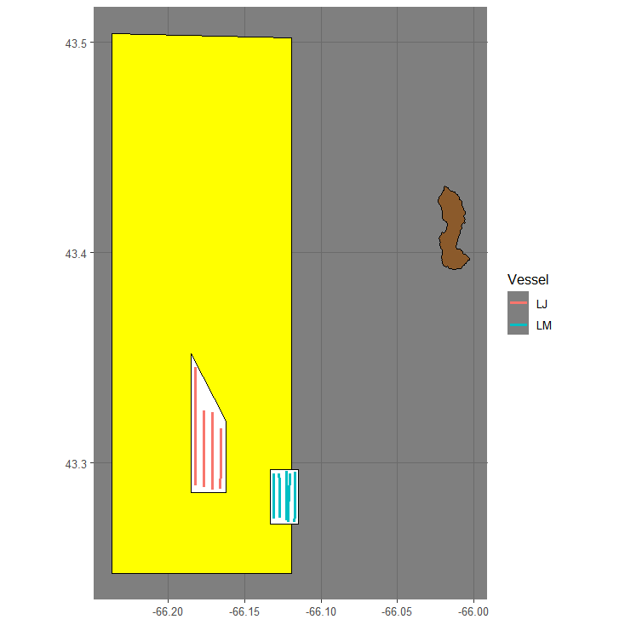

Figure 2. Transects ran with respect to the Seal Island box.

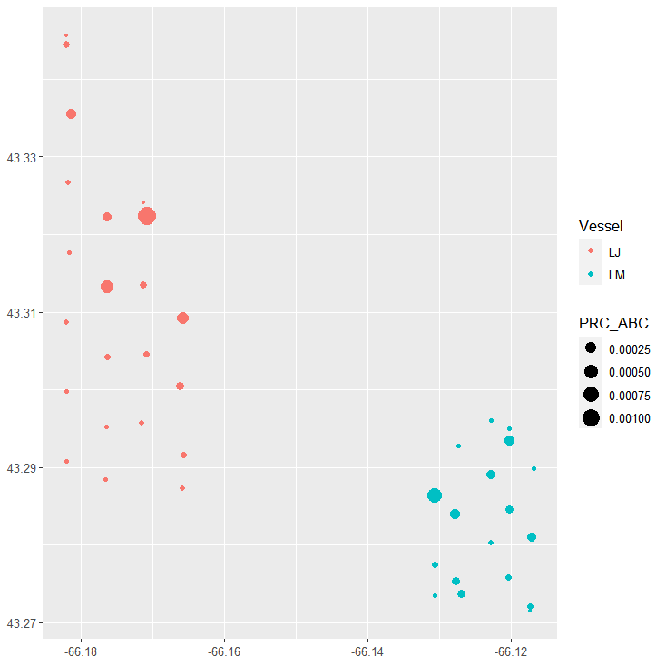

Figure 3. PRC Area Backscattering Coefficient (m2/m2) for each transect and cell using a grid of 1km.

Acoustic Equipment

The vessel was equipped with a Simrad ES38-18/200-18C combi (2-in-1) transducer prior to the survey that contains a 38kHz split beam and 200 kHz single beam transducer. Data was logged to the computer hard-drive for post-processing. The vessel was calibrated on 38kHz before the survey.

Results

The results are subject to change as DFO will re-evaluate data editing, area estimation and apply a target strength. Preliminary biomass prediction using standardized parallel transects is **7,322 mt for both surveys combined.**

Table 1. Transect details.



Table 2. Acoustic survey results - transects are listed from greatest to least backscatter.



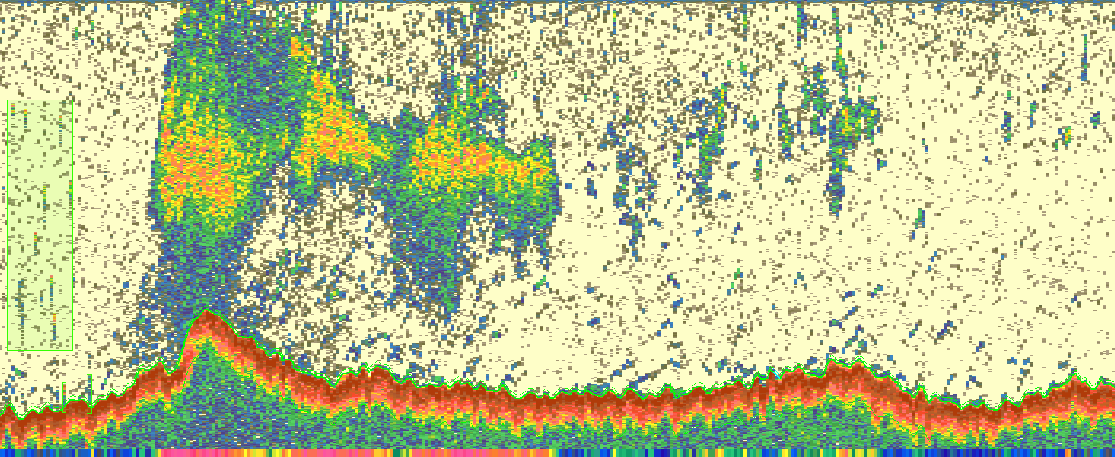

Figure 4. Snip from the transect with the greatest backscatter.

Table 3. Survey summary.

